9 May – NATURE OF GOD- God is MERCIFUL
STORY (2 Samuel 11:5-27)
Ask your child if they know what “mercy” means? Mercy means that if you do something wrong, the person that you have hurt doesn’t punish you for it.
David: Say that God is merciful. He forgives us when we do things wrong. This is a true story about how God showed mercy to a King called David.
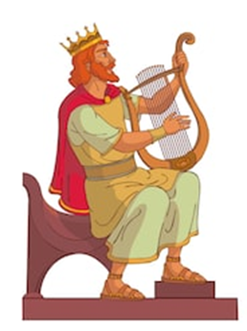
Crown: David was King of Israel. He was a good King and he loved God.
Soldier: Quite often, David and his army went to battle. They fought with the other countries around them.
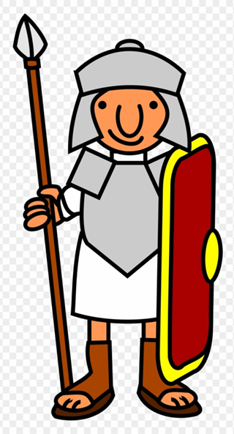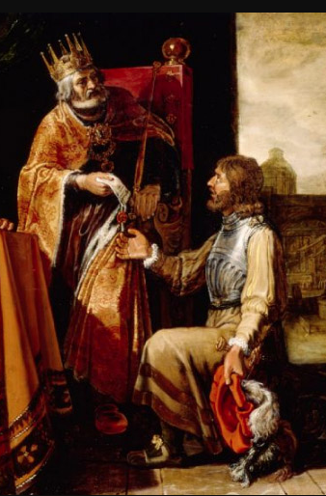
Uriah: One of David’s men was called Uriah. Uriah had a beautiful wife called Bathsheba.

Ring: David sent Uriah and all the rest of the army to war, but he stayed at home. He invited Bathsheba to dinner and then he decided he wanted to marry her. But he couldn’t, because she was married to Uriah already. Then David came up with a cunning plan. He knew that God wouldn’t like it, but he did it anyway. He arranged for Uriah to be killed while he was fighting. Uriah died and so David then married Bathsheba.
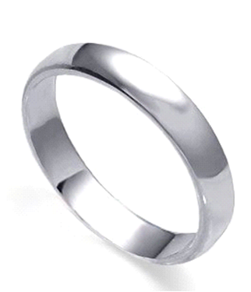
Angry face: But God wasn’t happy. God was furious. David deserved to be punished because he had killed Uriah. But David realised that he had done a very bad thing and he was sorry.
Man Praying: David decided to pray to God. He prayed for a long time and he asked God to forgive him for killing Uriah. And because David was sorry, God was merciful. David and Bathsheba lived together, and Bathsheba’s son was the next King of Israel after David died.
Say that we all do bad things – but God likes to be merciful to us and to forgive us.
Prayer time
Dear God, thank you that you are a merciful God, and that you forgive us when we are sorry.

CRAFT
  - Trace around your child’s feet and write the words mercy and goodness in them. Your child can then colour in or paint their feet.
Because God is merciful and good – mercy and goodness will always follow you! 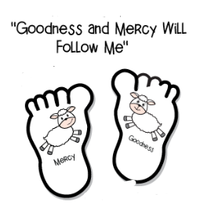
  - Make a crown and decorate it
Cut the yellow card in half lengthways. Use tape to secure the 2 pieces together.
Cut out zigzags on one side. Decorate. Use tape or staples to join together to make a crown.
