Jubilee Community Church Safeguarding Policy

The policy and procedures have been divided into five sections covering all 10 CCPAS safeguarding standards. Along with details of the organisation and a statement of intent and commitment to safeguarding, the policy covers the following sections:

Section 1. Place of worship / organisation details
Safe and Secure – Standard 1

Section 2. Recognising and responding appropriately to an allegation or suspicion of abuse
Safe and Secure – Standards 2 and 7

Section 3. Prevention
Safe and Secure – Standards 3 and 4

Section 4. Pastoral care
Safe and Secure – Standards 8 and 9

Section 5. Practice guidelines
Safe and Secure – Standards 5, 6 and 10

Appendices
Appendix 1. Leadership safeguarding statement
Appendix 2. Safeguarding Poster
Appendix 3. Good Practice Guidelines for Working with Children
Appendix 4. Handbooks and codes of practice
Appendix 5. Types of Adult Abuse
Appendix 6. Children - Definitions of abuse
Appendix 7. Signs and symptoms of possible abuse in children and young people
Appendix 8. How to respond to a child wishing to disclose abuse
Appendix 9. 0-18s Volunteer Team Recruitment Process
Appendix 10. contact numbers
Appendix 11 Declaration Form for staff and volunteers working with 0-18’s

The Safeguarding Policy
Section 1
Details of the place of worship / organisation
Name of Place of Worship / Organisation: Jubilee Community Church

Address: Jubilee Community Church,
Jubilee Community Centre,
Charlwoods Road,
East Grinstead,
West Sussex.
RH19 2HL

Tel No: 01342 328344 Email address: office@jcceg.co.uk

Membership of Denomination/Organisation: New Ground, New Frontiers, Evangelical Alliance, Churches Together in East Grinstead,

Charity Number: 1153068 and 274617 Company Number: 5860259

Regulators details (if any): None

Insurance Company- Ansvar Insurance

The following is a brief description of our place of worship / organisation and the type of work / activities we undertake with children / adults at risk:

Jubilee Community Church is a charismatic, evangelical group of Christians which is part of the New Ground stream of the New Frontiers family of churches. We provide a full range of ministries within out local area including; regular weekly meetings and outreach to young people and the elderly. Current information can be found on the church website: http://www.jcceg.co.uk/

Our commitment
As a Leadership we recognise the need to provide a safe and caring environment for children, young people and adults at risk. We acknowledge that children, young people and adults at risk can be the victims of physical, sexual and emotional abuse, and neglect. We accept the UN Universal Declaration of Human Rights and the International Covenant of Human Rights, which states that everyone is entitled to “all the rights and freedoms set forth therein, without distinction of any kind, such as race, colour, sex, language, religion, political or other opinion, national or social origin, property, birth or other status”. We also concur with the Convention on the Rights of the Child which states that children should be able to develop their full potential, free from hunger and want, neglect and abuse. They have a right to be protected from “all forms of physical or mental violence, injury or abuse, neglect or negligent treatment or exploitation, including sexual abuse, while in the care of parent(s), legal guardian(s), or any other person who has care of the child.” As a Leadership, we have therefore adopted the procedures set out in this safeguarding policy in accordance with statutory guidance. We are committed to build constructive links with statutory and voluntary agencies involved in safeguarding.

The policy and attached practice guidelines are based on the ten Safe and Secure safeguarding standards published by the Churches' Child Protection Advisory Service (CCPAS) and prepared in consultation with West Sussex County Council.

The Leadership undertakes to:
- endorse and follow all national and local safeguarding legislation and procedures, in addition to the international conventions outlined above.
- provide on-going safeguarding training for all its workers and will regularly review the operational guidelines attached.
- ensure that the premises meet the requirements of the Disability Discrimination Act 1995 and all other relevant legislation, and that it is welcoming and inclusive.
- support the Safeguarding Coordinators in their work and in any action they may need to take in order to protect children and adults at risk.
- file a copy of the policy and practice guidelines with CCPAS and the local authority, West Sussex Social Services, and any amendments subsequently published. The Leadership agrees not to allow the document to be copied by other organisations.

Section 2
Recognising and responding appropriately to an allegation or suspicion of abuse

Detailed definitions, and signs and symptoms of abuse, as well as how to respond to a disclosure of abuse can be found in appendices 4-7 of our policy.

Understanding abuse and neglect

Defining child abuse or abuse against an adult at risk is a difficult and complex issue. A person may abuse by inflicting harm, or failing to prevent harm. Children and adults in need of protection may be abused within a family, an institution or a community setting. Very often the abuser is known or in a trusted relationship with the child or adult at risk.

In order to safeguard those in our places of worship and organisations we adhere to the UN Convention on the Rights of the Child and have as our starting point as a definition of abuse, Article 19 which states:

1. States Parties shall take all appropriate legislative, administrative, social and educational measures to protect the child from all forms of physical or mental violence, injury or abuse, neglect or negligent treatment, maltreatment or exploitation, including sexual abuse, while in the care of parent(s), legal guardian(s) or any other person who has the care of the child.
2. Such protective measures should, as appropriate, include effective procedures for the establishment of social programmes to provide necessary support for the child and for those who have the care of the child, as well as for other forms of prevention and for identification, reporting, referral, investigation, treatment and follow-up of instances of child maltreatment described heretofore, and, as appropriate, for judicial involvement.
Also for adults the UN Universal Declaration of Human Rights with particular reference to Article 5 which states:
No one shall be subjected to torture or to cruel, inhuman or degrading treatment or punishment.

Safeguarding an Adult at risk (vulnerable adults)
The Care Act 2014 defines Adult Safeguarding as ‘Protecting an adult’s right to live in safety, free from abuse and neglect’. It is about people and organisations working together to prevent and stop both the risks and experience of abuse or neglect, while at the same time making sure that the adult’s well-being is promoted, including, where appropriate, having regard to their views, wishes, feelings and beliefs in deciding on any action’.

This must recognise that adults sometimes have complex interpersonal relationships and may be ambivalent, unclear or unrealistic about their personal circumstances
The Care Act 2014 identifies an adult at risk as being an adult who:
- Has needs for care and support (whether or not the local authority is meeting any of those needs) and;
- Is experiencing, or at risk of, abuse and neglect; and
- As a result of those care and support needs is unable to protect themselves from either the risk of, or the experience off abuse or neglect

Adults ‘who may be eligible to community care services’ are those whose independence and well-being would be at risk if they did not receive appropriate health and social care support. The person may be:

- Living in their own home
- In hospital
- In a residential care or nursing home
- Attending a clinical setting
(the above list is not intended to be exhaustive)

Safeguarding awareness
The Leadership is committed to on-going safeguarding training and development opportunities for all workers, developing a culture of awareness of safeguarding issues to help protect everyone. All our workers will receive induction training and undertake recognised safeguarding training on a regular basis. All relevant personnel will be required to attend any in-house training such as, “Facing the Unthinkable” seminar run by CCPAS.
The Leadership will also ensure that children and adults at risk are provided with information on where to get help and advice in relation to abuse, discrimination, bullying or any other matter where they have a concern.

RESPONDING TO ALLEGATIONS OF ABUSE

Under no circumstances should a worker carry out their own investigation into an allegation or suspicion of abuse. If a child or vulnerable adult is in immediate danger, ring 999 and ask for police. Otherwise, follow procedures as below:

- The person in receipt of allegations or suspicions of abuse should report concerns as soon as possible to Cris Payne (hereafter the "Safeguarding Co-ordinator") tel no: 01342 01342 or 07933138197 who is nominated by the Leadership to act on their behalf in dealing with the allegation or suspicion of neglect or abuse, including referring the matter on to the statutory authorities.

- In the absence of the Safeguarding Co-ordinator or, if the suspicions in any way involve the Safeguarding Co-ordinator, then the report should be made to Christine Maclean (hereafter the "Deputy ") tel no: 01342 716099 or 07584040663 If the suspicions implicate both the Safeguarding Co-ordinator and the Deputy, then the report should be made in the first instance to the Churches' Child Protection Advisory Service (CCPAS) PO Box 133, Swanley, Kent, BR8 7UQ. Telephone 0845 120 4550. Alternatively contact Social Services or the police.

- Where the concern is about a child the Safeguarding Co-ordinator should contact Children’s Social Services. Where the concern is regarding an adult in need of protection, contact Adult Social Services or take advice from CCPAS as above.
The local Children’s Access Point number (office hours) is 01403 229900

The local Adult Social Services office telephone number (office hours) is. 01243 642121

Sussex Police (non emergency) can be contacted on 101

- Where required, the Safeguarding Co-ordinator should then immediately inform the insurance company and the Lead Elder, Simon Elliot Tel no: 01342 321966

- Suspicions must not be discussed with anyone other than those nominated above. A written record of the concerns should be made in accordance with these procedures and kept in a secure place.

- Whilst allegations or suspicions of abuse will normally be reported to the Safeguarding Co-ordinator, the absence of the Safeguarding Co-ordinator or Deputy should not delay referral to Social Services, the Police or taking advice from CCPAS.

- The Leadership will support the Safeguarding Co-ordinator/Deputy in their role, and accept that any information they may have in their possession will be shared in a strictly limited way on a need to know basis.

- It is, of course, the right of any individual as a citizen to make a direct referral to the safeguarding agencies or seek advice from CCPAS, although the Leadership hope that members of the place of worship / organisation will use this procedure. If, however, the individual with the concern feels that the Safeguarding Co-ordinator/Deputy has not responded appropriately, or where they have a disagreement with the Safeguarding Co-ordinator(s) as to the appropriateness of a referral they are free to contact an outside agency direct. We hope by making this statement that the Leadership demonstrate its commitment to effective safeguarding and the protection of all those who are vulnerable.
- The role of the safeguarding co-ordinator/ deputy is to collate and clarify the precise details of the allegation or suspicion and pass this information on to statutory agencies who have a legal duty to investigate. Where this involves an adult at risk, she will seek to obtain the person’s consent and explain what information may be shared with other people or organisations. Where a person lacks capacity to give consent a Best Interests decision to share the information must be made. Safeguarding Adults at Risk establishes a general principle that information about an incident of suspected or actual abuse can be reported more widely where appropriate for example if the allegation involves a person who is employed or volunteering in a position of trust.

Detailed procedures where there is a concern about a child:

ALLEGATIONS OF PHYSICAL INJURY, NEGLECT OR EMOTIONAL ABUSE

If a child has a physical injury, a symptom of neglect or where there are concerns about emotional abuse, the Safeguarding Co-ordinator/Deputy will:

- Contact Children’s Social Services (or CCPAS) for advice in cases of deliberate injury, if concerned about a child's safety or if a child is afraid to return home.

- Not tell the parents or carers unless advised to do so, having contacted Children’s Social Services.

- Seek medical help if needed urgently, informing the doctor of any suspicions.

- For lesser concerns, (e.g. poor parenting), encourage parent/carer to seek help, but not if this places the child at risk of significant harm.

- Where the parent/carer is unwilling to seek help, offer to accompany them. In cases of real concern, if they still fail to act, contact Children’s Social Services direct for advice.

- Seek and follow advice given by CCPAS (who will confirm their advice in writing) if unsure whether or not to refer a case to Children’s Social Services.

ALLEGATIONS OF SEXUAL ABUSE

In the event of allegations or suspicions of sexual abuse, the Safeguarding Co-ordinator/Deputy will:

- Contact the Children’s Social Services Department Duty Social Worker for children and families or Police Child Protection Team direct. They will NOT speak to the parent/carer or anyone else.

- Seek and follow the advice given by CCPAS if, for any reason they are unsure whether or not to contact Children’s Social Services/Police. CCPAS will confirm its advice in writing for future reference.

The following procedure will be followed where there is a concern that an adult is in need of protection:
ADULTS - SUSPICIONS OR ALLEGATIONS OF ABUSE

Where there is a suspicion or where an adult at risk makes a disclosure about abuse the Safeguarding Co-ordinator/Deputy will:

  - Discuss any concerns with the individual themselves giving due regard to their autonomy, privacy and rights to lead an independent life.

  - Always seek the consent of the individual before taking any action or sharing personal information.

  - However, there may be circumstances when consent cannot be obtained because the adult lacks the capacity to give it, but the best interests of the individual or others at risk, demand action. If after discussion with the adult at risk who has mental capacity, they refuse any intervention; their wishes will be respected unless:

- There is a public interest, for example, not acting will put other adults or children at risk
- There is a duty of care to intervene, for example, a crime has been or may be committed
- The person alleged to have caused harm is employed in a position of trust, such as a health, social care or pastoral professional

- If the person is in immediate danger or has sustained a serious injury contact the Emergency Services, informing them of any suspicions.

- For advice contact the Adult Social Care Safeguarding Adults Team who have responsibility under Section 42 of the Care Act 2014 to make or cause an enquiry to be made regarding all safeguarding referrals. Alternatively CCPAS can be contacted for advice.

ALLEGATIONS OF ABUSE AGAINST A PERSON WHO WORKS WITH CHILDREN
If an accusation is made against a worker (whether a volunteer or paid member of staff) whilst following the procedure outlined above, the Safeguarding Co-ordinator, in accordance with Local Safeguarding Children Board (LSCB) procedures will need to liaise with Children’s Social Services in regards to the suspension of the worker, also making a referral to a Safeguarding Adviser (SA) / Local Authority Designated Officer (LADO).

Section 3
Prevention

Safe recruitment

The Leadership will ensure all workers will be appointed, trained, supported and supervised in accordance with government guidance on safe recruitment. This includes ensuring that:

- There is a written job description / person specification for the post
- Those applying have completed an application form and a self declaration form
- Those short listed have been interviewed
- Safeguarding has been discussed at interview
- Written references have been obtained, and followed up where appropriate
- A criminal records disclosure has been completed (we will comply with Code of Practice requirements concerning the fair treatment of applicants and the handling of information)
- Qualifications where relevant have been verified
- A suitable training programme is provided for the successful applicant
- The applicant has completed a probationary period
- The applicant has been given a copy of the organisation’s safeguarding policy and knows how to report concerns.
- Attempts will be made to obtain a good conduct certificate from any applicants working for the church, either paid or unpaid, who have come from aboard. This will be obtained from the police, or other agency or institution where the person has been involved. Guidance from CCPAS’s ‘Safe and Secure’ manual will be followed.
- Should the church run any projects or activities which involve children or young people staying with a host family, any occupants of the household will need to be subject to a DBS check.

Management of Workers – Codes of Conduct

As a Leadership we are committed to supporting all workers and ensuring they receive support and supervision. In addition to regular meetings and Safeguarding Training, all workers have been issued with a code of conduct relevant to their area of ministry.
The Leadership undertakes to follow the principles found within the ‘Abuse Of Trust ‘guidance issued by the Home Office and it is therefore unacceptable for those in a position of trust to engage in any behaviour which might allow a sexual relationship to develop for as long as the relationship of trust continues.

More detailed guidance can be found at- http://www.ccpas.co.uk/Documents/AbuseOfTrustQRG.pdf
. This guidance is intended to apply to those caring for young people or vulnerable adults in both paid and unpaid work, including volunteers, regardless of whether they are in the public, private, voluntary or volunteering sectors. It is important that places of worship and organisations have clear boundaries in regards to the personal relationships which can develop.

Section 4
Pastoral Care

Supporting those affected by abuse

The Leadership is committed to offering pastoral care, working with statutory agencies as appropriate, and support to all those who have been affected by abuse who have contact with or are part of the place of worship / organisation. At the elders’ discretion, affected people will be offered support from an identified, accredited counsellor.

Working with offenders

When someone attending Jubilee Community Church is known to have abused children, or is known to be a risk to adults at risk, the Leadership will supervise the individual concerned and offer pastoral care. However, in its safeguarding commitment to the protection of children and adults at risk, in consultation with CCPAS and informed, if possible, by risk assessments from the statutory agencies, The Leadership will set boundaries for that person which they will be expected to keep.

Whilst it is recognised that preferable practice would be to work towards a contractual agreement with sex offenders, as an interim arrangement, Jubilee Community Church will not permit a known sex offender to have contact with children or adults at risk at an event or meeting for which it is responsible. All known offenders will be personally supervised by a person within the leadership team.

Section 5
Practice Guidelines

As an organisation / place of worship working with children, young people and adults at risk we wish to operate and promote good working practice. This will enable workers to run activities safely, develop good relationships and minimise the risk of false accusation.
As well as a general code of conduct for workers (appendix 3 entitled Good Practice Guide for Working with Children), we also have specific good practice guidelines for every activity we are involved in and these can also be found in the appendices.

Many Jubilee Community Church activities take place in Jubilee Community Centre, such as; Little Stars, Glo worms and Sparklers providing for pre-school children, Blaze- providing for children in school years 1 to 6 , Ignite- providing for children in school years 7-9, Encounter- providing for children in school years 10-13, Bowls and Link Up- a group providing for older adults, some of whom are considered vulnerable. Consent forms will be obtained, where necessary, for any suitable, additional activity with the children or adults at risk.

Jubilee Community Centre is a venue for other organisations' activities. Whilst Jubilee Community Church activities are taking place and the front door is unlocked, the lobby area will be supervised by a Duty Manager or an appointed deputy. The Duty Manager or appointed deputy will make it their business to ensure that they know why any person visiting the premises is there. If they are unsure, the person will be asked to confirm why they are in the building and where they are going within the building. The Duty Manager or appointed deputy should monitor the movements of everyone who passes through the lobby and, if they are uncertain or suspicious about anything they should investigate as appropriate in the interests of the Safeguarding objectives of this policy.

Working in Partnership

The diversity of organisations and settings means there can be great variation in practice when it comes to safeguarding children, young people and adults at risk. This can be because of cultural tradition, belief and religious practice or understanding, for example, of what constitutes abuse.
We therefore have clear guidelines in regards to our expectations of those with whom we work in partnership, whether in the UK or not. We will discuss with all partners our safeguarding expectations and have a partnership agreement for safeguarding. It is also our expectation that any organisation using our premises, as part of the letting agreement will have their own policy that meets CCPAS’ safeguarding standards.

Good communication is essential in promoting safeguarding, both to those we wish to protect, to everyone involved in working with children and adults at risk and to all those with whom we work in partnership. This safeguarding policy is just one means of promoting safeguarding.

In order to promote and communicate the safe guarding message, posters will be displayed throughout the Jubilee Community Centre which provides the CCPAS helpline number.

Signed by: ____Simon Elliott / Mark Berry____________________________

Date: ____________Jan 2016____________________

Appendix 1
Leadership Safeguarding Statement
Jubilee Community Church, East Grinstead
The Leadership at Jubilee Community Church East Grinstead recognises the importance of its ministry /work with children and young people and adults in need of protection and its responsibility to protect everyone entrusted to our care.
The following statement was agreed by them on: 1st January 2016
This church is committed to the safeguarding of children and adults at risk and ensuring their well-being.
Specifically:
- We recognise that we all have a responsibility to help prevent the physical, sexual, emotional abuse and neglect of children and young people (those under 18 years of age) and to report any such abuse that we discover or suspect.
- We believe every child should be valued, safe and happy. We want to make sure that children we have contact with know this and are empowered to tell us if they are suffering harm.
- All children and young people have the right to be treated with respect, to be listened to and to be protected from all forms of abuse.
- We recognise that we all have a responsibility to help prevent the abuse and neglect of adults at risk and to report any such abuse that we discover or suspect.
- We recognise the personal dignity and rights of adults at risk and will ensure all our policies and procedures reflect this.
- We believe all adults should enjoy and have access to every aspect of the life of the church unless they pose a risk to the safety of those we serve.
- We undertake to exercise proper care in the appointment and selection of all those who will work with children and adults at risk.
We are committed to:
- Following the requirements for UK legislation in relation to safeguarding children and adults at risk and good practice recommendations.
- Respecting the rights of children as described in the UN Convention on the Rights of the Child.
- Implementing the requirements of legislation in regard to people with disabilities.
- Ensuring that workers adhere to the agreed procedures of our safeguarding policy.
- Keeping up to date with national and local developments relating to safeguarding.
- Following any denominational or organisational guidelines in relation to safeguarding children and adults in need of protection.
- Supporting the safeguarding co-ordinators in their work and in any action they may need to take in order to protect children/adults at risk.
- Ensuring that everyone agrees to abide by these recommendations and the guidelines established by this place of worship/organisation.
- Supporting parents and families
- Nurturing, protecting and safeguarding of children and young people
- Supporting, resourcing, training, monitoring and providing supervision to all those who undertake this work.
- Supporting all in the place of worship/organisation affected by abuse.
- Adopting and following the ‘Safe and Secure’ safeguarding standards developed by the Churches’ Child Protection Advisory Service.
We recognise:
- Children’s Social Services (or equivalent) has lead responsibility for investigating all allegations or suspicions of abuse where there are concerns about a child. Adult Social Care (or equivalent) has lead responsibility for making or causing an enquiry to be made regarding all allegations or suspicions of abuse where there are concerns about an adult at risk..
- Where an allegation suggests that a criminal offence may have been committed then the police should be contacted as a matter of urgency.
- Where working outside of the UK, concerns will be reported to the appropriate agencies in the country in which we operate, and their procedures followed, and in addition we will report concerns to our agency’s headquarters.
- Safeguarding is everyone’s responsibility.
We will review this statement and our policy and procedures annually.
If you have any concerns for a child or adult at risk then speak to one of the following who have been approved as safeguarding co-ordinators for this place of worship/organisation.
0-18’s
Cris Payne______________________________________Child Safeguarding Coordinator
Christine Maclean ________________ Deputy Child Safeguarding Coordinator
Vulnerable Adults
Christine Maclean__________________________Adult Safeguarding Coordinator
Cris Payne __________________________Deputy Adult Safeguarding Coordinator
A copy of the full policy and procedures is available from the church leaders, Jubilee Community Centre reception or the Safeguarding Co-ordinators.
A copy of our safeguarding policy has been lodged with CCPAS as well as West Sussex County Council.

Signed Simon Elliott (Lead Elder), Mark Berry (Chair of Trustees)
(signed copy in church files) Date: 13th Feburary, 2016
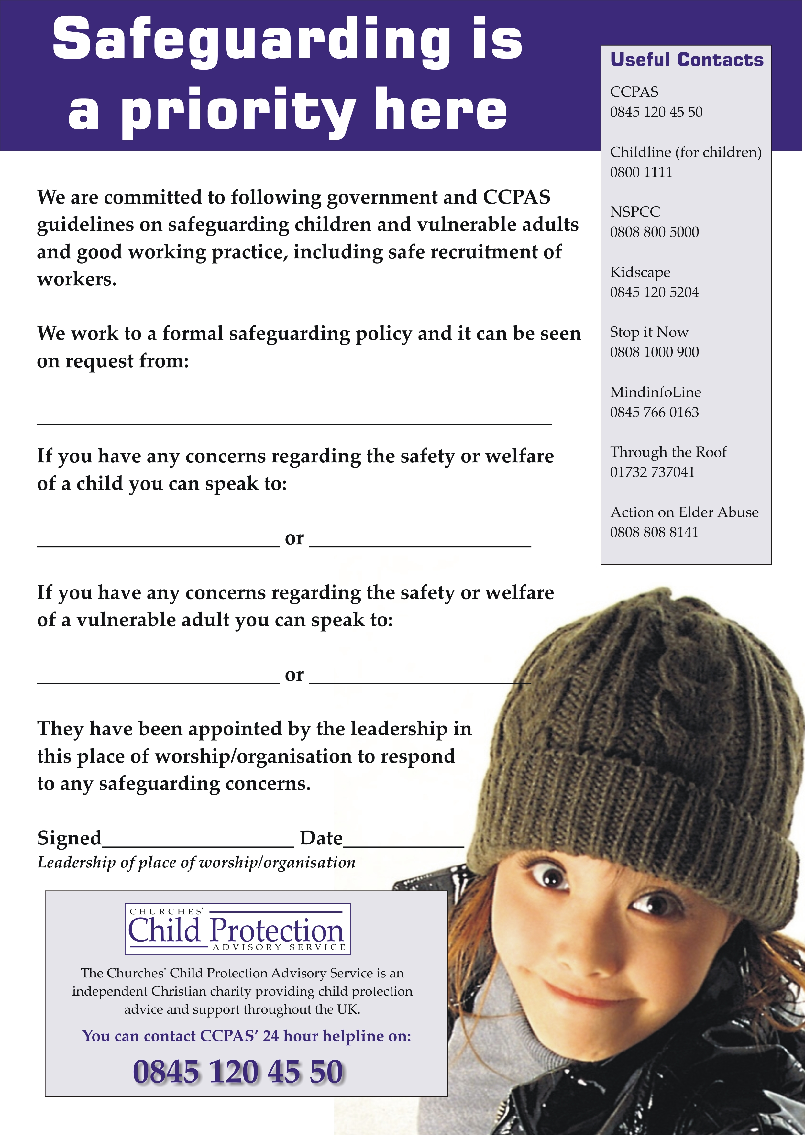

APPENDIX 3- Good Practice Guidelines for Working with Children

PHYSICAL CONTACT, TOUCH, INTERVENTION/RESTRAINT, COMFORTING A DISTRESSED CHILD/YOUNG PERSON
A no touch approach for adults who work with children/young people is often impractical. Every child/young person is different and every situation is unique therefore adult leaders should maintain self awareness of the dynamic of each situation and judge what is appropriate based on the needs of the individual child/young person. Any such contact will need to be age and gender appropriate and of limited duration. Where a child/young person seeks out or initiates physical contact with an adult leader, the situation should be handled with sensitivity and must never be exploited. Physical contact should never be secretive or for the gratification of the adult

Physical intervention should, where possible be avoided. However there are occasions when the use of physical intervention is appropriate in order to control or prevent a potentially dangerous or harmful situation. The scale of any such intervention must be proportionate to the behaviour and the nature of the harm they may cause. The minimum necessary force should be used.

BULLYING AND SPIRITUAL ABUSE
Bullying is any behavior that is deliberately intended to hurt, threaten or frighten another person or group of people. It may include physical attacks, swearing and insulting comments, or deliberately leaving someone out of things. There is currently an increase in cyber bullying or bullying using mobile technology.

Bullying of any kind is not acceptable, whether it is aimed at children, young people or adults. For further help, information, resources or advice see- www.childline.org.uk/extra/bullyingindex.asp
www.anti-bullyingalliance.org.uk

Spiritual abuse is another form of bullying and is also not acceptable as it can seriously affect the development of children/young.

YOUTH WORK AND THE INTERNET
When the youth/children’s group uses the internet as part of their work, there should be a policy and clear guidelines on how it is to be used and there should always be adult supervision. The Codes of Practice have clear guidelines on the use of texting or social media. No youth helper has any reason to contact under 18’s outside of the planned meetings. The Leadership team and Disciplers may need to do so, but should abide by the guidance given in the Disciplers’ Code of Conduct and only with the knowledge and permission of parents.

CHILD PROTECTION POLICIES AND PROCEDURES
Ensure all paid workers and adult volunteers have followed/completed the safe recruitment procedures and have obtained a clear enhanced DBS disclosure before being allowed to supervise young people. Different coloured lanyards or badges will be used to distinguish between probationers and full team members.

Ensure all who work with children/young people know what to do in the case of suspected or alleged abuse.
Respect confidentiality but never promise to keep secrets especially if a young person is at harm or risk of being harmed.

All who work with children/young people are responsible for their own actions and behaviour and should avoid any conduct which would lead any reasonable person to question their motivation and intentions.

All who work with children/young people should work and be seen to work, in an open and transparent way and should continually monitor and review their practice.

LEADERS, VOLUNTEERS AND HELPERS
Much of the youth and children’s work that happens in the faith sector is run by a committed group of volunteers therefore we must ensure that:
- Inexperienced leaders/workers/volunteers and young volunteers will benefit from clear guidance and supervision.
- All who work with children/ young people need to think and act carefully to avoid situations which could lead to difficulties, embarrassing situations, accusations or temptations.
- All who work with children/young people should be encouraged to participate in regular training.
- Young volunteers (under the age of 18) should never be left on their own to run a group.

SAFE RATIOS AND GENDER REPRESENTATION
There should always be a minimum of two adult leaders at every session, ideally one male and one female. However it is recognized that this is not always possible.

IMPORTANT INFORMATION, PERMISSIONS AND CONSENT
Up to date relevant information, and obtaining consent is a vital part of safeguarding children and young people.

A register of up-to-date information and contact details must be kept of the children/young people you work with. It is also recommended that up-to-date information and contact details of the staff is also kept. All must be stored safely.

It is good practice to keep an incident/accident book where incidents or accident can be recorded for future reference if required.

For any activities away from the normal meeting place; ensure that parents/guardians know where the group is going, and that they have signed and returned the relevant consent form.

Consent will also need to be obtained if leaders are going to take photographs or videos of children/young people, especially if they are for public viewing. These images should be sent to the 0-18’s co-ordinator as soon as possible and deleted from any private digital storage device.

Appendix 4 Handbooks and codes of practice
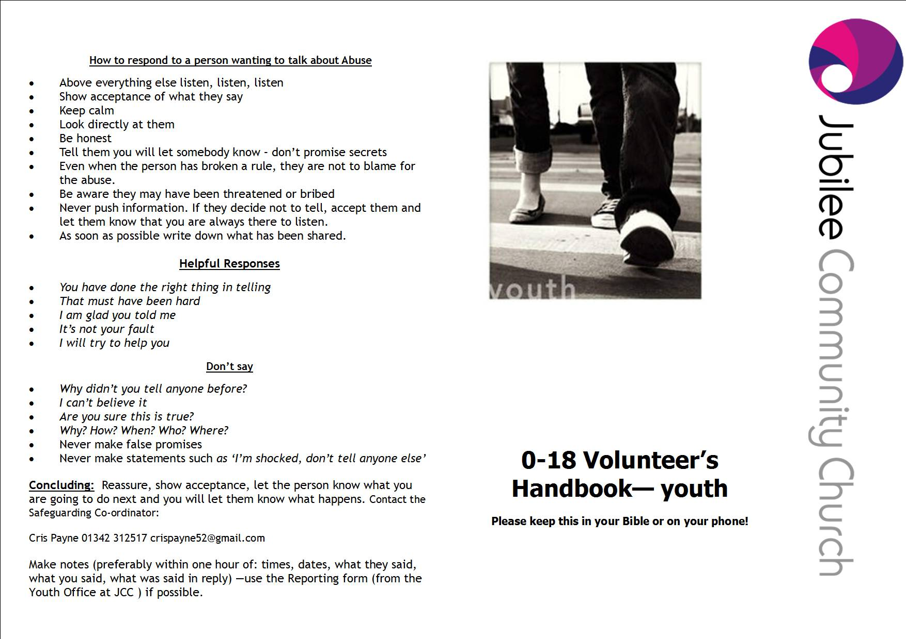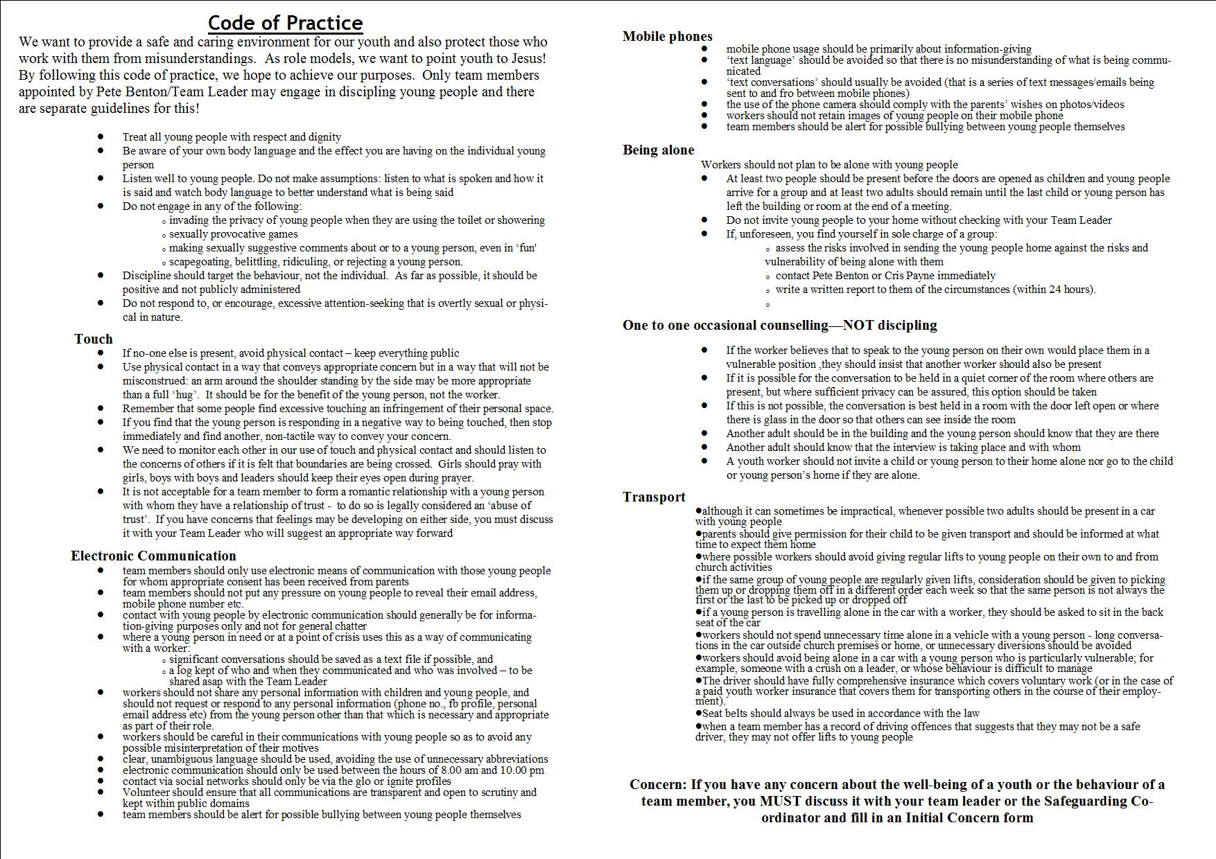

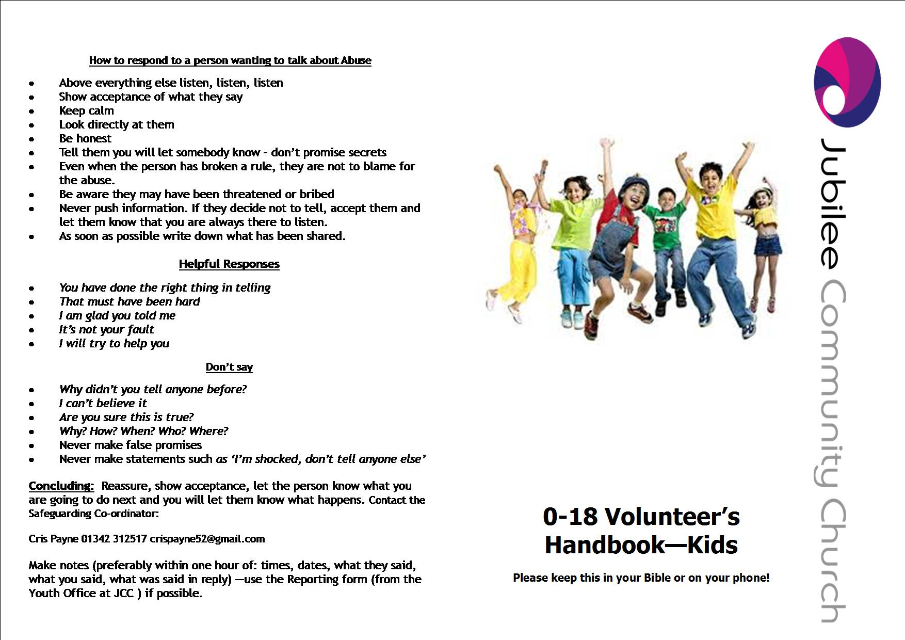
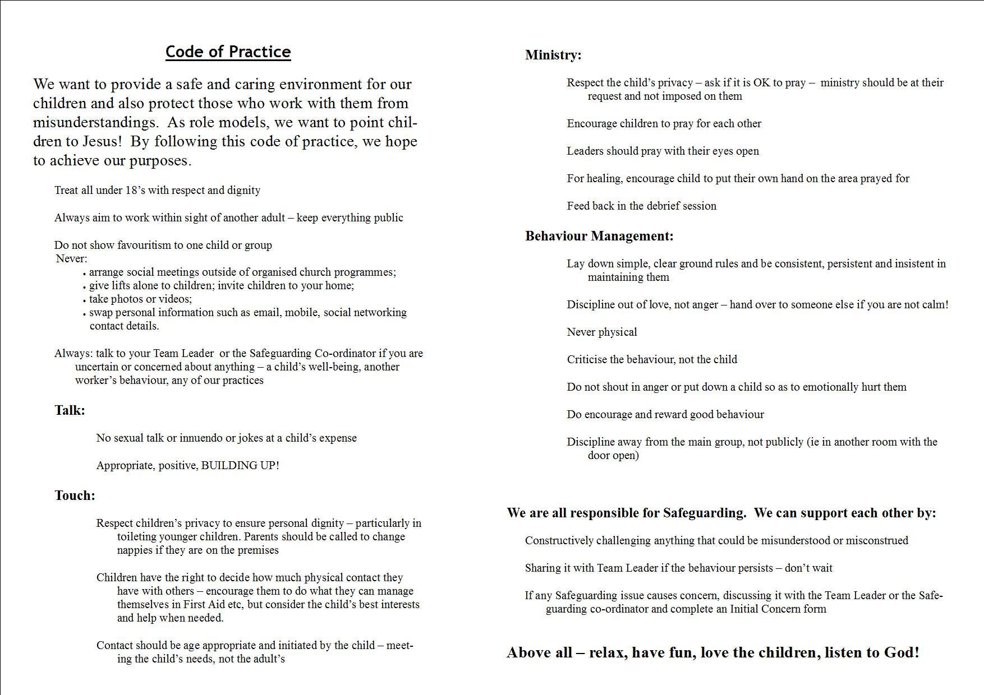

Appendix 5
The Types of Adult Abuse are:

Physical abuse –including assault, hitting, slapping, pushing, kicking,

misuse of medication, restraint or inappropriate physical sanctions

Sexual abuse – including rape, indecent exposure, sexual harassment, inappropriate looking or touching, sexual teasing or innuendo, sexual photography, subjection to pornography or witnessing sexual acts to which the adult has not consented or was pressurised into consenting
Psychological abuse – including emotional abuse, threats of harm or abandonment, deprivation of contact, humiliation, blaming, controlling, intimidation, coercion, harassment, verbal abuse, cyber bullying, isolation or unreasonable and unjustified withdrawal of services or supportive networks

Financial or material abuse - including theft, fraud, internet scamming, coercion in relation to an adults financial affairs or arrangements, including in connection with wills, property, inheritance, financial transactions, or the misuse or misappropriation of property, possessions of benefits

Neglect and acts of omission –including ignoring medical emotional or physical care needs, failure to provide access to appropriate health, care and support or educational services, the withholding of the necessities of life, such as medication, adequate nutrition and heating

Discriminatory abuse – including forms of harassment, slurs or similar treatment because of race, gender and gender identity, age, disability, sexual orientation or religion

Organisational abuse – including neglect and poor care practice within an institution or specific care setting such as a hospital or care home or in relation to care provided in a person’s own home. This may range from one off incidents to on-going ill-treatment. It can be through neglect or poor professional practice as a result of the structure, policies, processes and practices within an organisation

Domestic Violence – Incidents or patterns of controlling, coercive or threatening behaviour, violence or abuse by someone who is or has been an intimate partner or family member regardless of gender or sexuality. This can include psychological, physical, sexual, financial, emotional abuse, so call ‘honour’ based violence

Self-Neglect – This covers a wide range of behaviour neglecting to care for one’s personal hygiene, health or surroundings and includes behaviours such as hoarding

Modern Slavery – encompasses slavery, human trafficking, forced labour and domestic servitude. Traffickers and slave masters use whatever means they have at their disposal to coerce, deceive and force individuals into a life of abuse, servitude and inhumane treatment. Incidents may be a one-off or multiple and affect one person or more
(Based on guidance in The Care Act 2014)

Appendix 6
Children - Definitions of abuse
The four definitions of abuse below operate in England based on the government guidance ‘Working Together to Safeguard Children (2010)’.
Physical abuse
Physical abuse may involve hitting, shaking, throwing, poisoning, burning or scalding, drowning, suffocating, or otherwise causing physical harm to a child. Physical harm may also be caused when a parent or carer fabricates the symptoms of, or deliberately induces, illness in a child.
Emotional abuse
Emotional abuse is the persistent emotional maltreatment of a child such as to cause severe and persistent adverse effects on the child’s emotional development.
It may involve conveying to children that they are worthless or unloved, inadequate, or valued only insofar as they meet the needs of another person. It may include not giving the child opportunities to express their views, deliberately silencing them or ‘making fun’ of what they say or how they communicate. It may feature age or developmentally inappropriate expectations being imposed on children. These may include interactions that are beyond the child’s developmental capability, as well as overprotection and limitation of exploration and learning, or preventing the child participating in normal social interaction. It may involve seeing or hearing the ill-treatment of another. It may involve serious bullying (including cyber bullying), causing children frequently to feel frightened or in danger, or the exploitation or corruption of children. Some level of emotional abuse is involved in all types of maltreatment of a child, though it may occur alone.
Sexual abuse
Sexual abuse involves forcing or enticing a child or young person to take part in sexual activities, not necessarily involving a high level of violence, whether or not the child is aware of what is happening. The activities may involve physical contact, including assault by penetration (for example, rape or oral sex) or non-penetrative acts such as masturbation, kissing, rubbing and touching outside of clothing. They may also include non-contact activities, such as involving children in looking at, or in the production of, sexual images, watching sexual activities, encouraging children to behave in sexually inappropriate ways, or grooming a child in preparation for abuse (including via the internet). Sexual abuse is not solely perpetrated by adult males. Women can also commit acts of sexual abuse, as can other children.
Neglect
Neglect is the persistent failure to meet a child’s basic physical and/or psychological needs, likely to result in the serious impairment of the child’s health or development. Neglect may occur during pregnancy as a result of maternal substance abuse. Once a child is born, neglect may involve a parent or carer failing to:
- provide adequate food, clothing and shelter (including exclusion from home or abandonment);
- protect a child from physical and emotional harm or danger;
- ensure adequate supervision (including the use of inadequate care-givers); or
- ensure access to appropriate medical care or treatment.
It may also include neglect of, or unresponsiveness to, a child’s basic emotional needs.

Appendix 7
Signs and symptoms of possible abuse in children and young people
The following signs could be indicators that abuse has taken place but should be considered in context of the child’s whole life.

Physical
Injuries not consistent with the explanation given for them
Injuries that occur in places not normally exposed to falls, rough games, etc
Injuries that have not received medical attention
Reluctance to change for, or participate in, games or swimming
Repeated urinary infections or unexplained tummy pains
Bruises on babies, bites, burns, fractures etc which do not have an accidental explanation*
Cuts/scratches/substance abuse*

Sexual
Any allegations made concerning sexual abuse
Excessive preoccupation with sexual matters and detailed knowledge of adult sexual behavior
Age-inappropriate sexual activity through words, play or drawing
Child who is sexually provocative or seductive with adults
Inappropriate bed-sharing arrangements at home
Severe sleep disturbances with fears, phobias, vivid dreams or nightmares, sometimes with overt or veiled sexual connotations
Eating disorders - anorexia, bulimia*

Emotional
Changes or regression in mood or behavior, particularly where a child withdraws or becomes clinging.
Depression, aggression, extreme anxiety
Nervousness, frozen watchfulness
Obsessions or phobias
Sudden under-achievement or lack of concentration
Inappropriate relationships with peers and/or adults
Attention-seeking behavior
Persistent tiredness
Running away/stealing/lying

Neglect
Under nourishment, failure to grow, constant hunger, stealing or gorging food, Untreated illnesses,
Inadequate care, etc

*These indicate the possibility that a child or young person is self-harming. Approximately 20,000 are treated in accident and emergency departments in the UK each year.

Appendix 8
How to respond to a child wishing to disclose abuse
Effective Listening
Ensure the physical environment is welcoming, giving opportunity for the child or vulnerable adult to talk in private but making sure others are aware the conversation is taking place.
It is especially important to allow time and space for the person to talk.
Above everything else listen without interrupting.
Be attentive and look at them whilst they are speaking.
Show acceptance of what they say (however unlikely the story may sound) by reflecting back words or short phrases they have used.
Try to remain calm, even if on the inside you are feeling something different.
Be honest and don’t make promises you can’t keep regarding confidentiality.
If they decide not to tell you after all, accept their decision but let them know that you are always ready to listen.
Use language that is age appropriate and, for those with disabilities, ensure there is someone available who understands sign language, Braille etc.

HELPFUL RESPONSES
You have done the right thing in telling.
I am glad you have told me.
I will try to help you.

DON'T SAY
Why didn't you tell anyone before?
I can't believe it!
Are you sure this is true?
Why? How? When? Who? Where?
I am shocked, don't tell anyone else
Appendix 9

0-18s Volunteer Team Recruitment Process
 |  | Who is responsible?
1 | Someone is interested in volunteering
2 | Team leader gives them a copy of the Volunteer Role Description (Appendix 2) as well as a JCC 0-18s Volunteer Application Form (Appendix 1) | Team leader
3 | Potential volunteer completes application form and returns it to 0-18s Coordinator | 0-18s Coordinator
4 | 0-18s Coordinator arranges an interview between the team leader, the safeguarding coordinator and the potential volunteer. | 0-18s Coordinator
5 | Interview takes place.  Safeguarding Policy and Codes of Practice are given to potential volunteer and Volunteer Role Description is signed.  Identification is shown and photocopied by Safeguarding Coordinator | Safeguarding Coordinator/Team Leader
6 | Details of DBS login is emailed to potential volunteer for them to complete at home. | Safeguarding Coordinator
7 | 0-18s Coordinator follows up references supplied by potential volunteer. | 0-18s Coordinator
8 | Safeguarding completes DBS checking. | Safeguarding Coordinator
9 | DBS checks are returned and Safeguarding Coordinator informs Team leader, Volunteer and 0-18s Coordinator of new recruit. | Safeguarding Coordinator

Appendix 10
In case of concern, contact:
 | Home numbers | office hours | out of hours emergency numbers
Cris Payne, Jubilee Community Church 0-18’s Safeguarding Co-ordinator | 01342 312517 or  07933138197
Christine Maclean, , Jubilee Community Church Adult Safeguarding Co-ordinator | 01342 716099 or 07584040663
Churches' Child Protection Advisory Service (CCPAS) PO Box 133, Swanley, Kent, BR8 7UQ. |  | 0845 120 4550
The local Children’s Social Services office |  | 01403 229900
The local Adult Social Services office |  | 01243 642121
The Police Child Protection Team |  | premium number 0845 6070999  or 101 | 999

Appendix 11 Declaration Form for staff and volunteers working with 0-18’s
Please sign and return to 0-18’s co-ordinator (Kat Gunter) (can be cut and pasted into an email if you wish)
I have read the Jubilee Community Church Safeguarding Policy for 2016/17 and agree to uphold the principles and procedures contained within it.

Name:

Role:

Team:

Date:

Signed:

